**Setup SQLite Database**

**Environment Software/Tools Setup:**

1. Download and Install DBeaver community edition.
   1. <https://dbeaver.io/>
2. Open DBeaver.
3. Click on “New Database Connection” on top left corner. Please refer below screenshot.

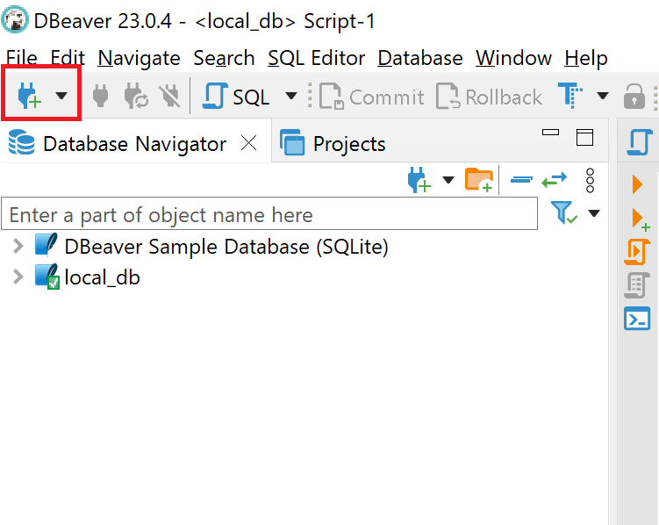

1. This will open a dialog box with a list of different databases. Please select SQLite database from the list. Please refer below screenshot.

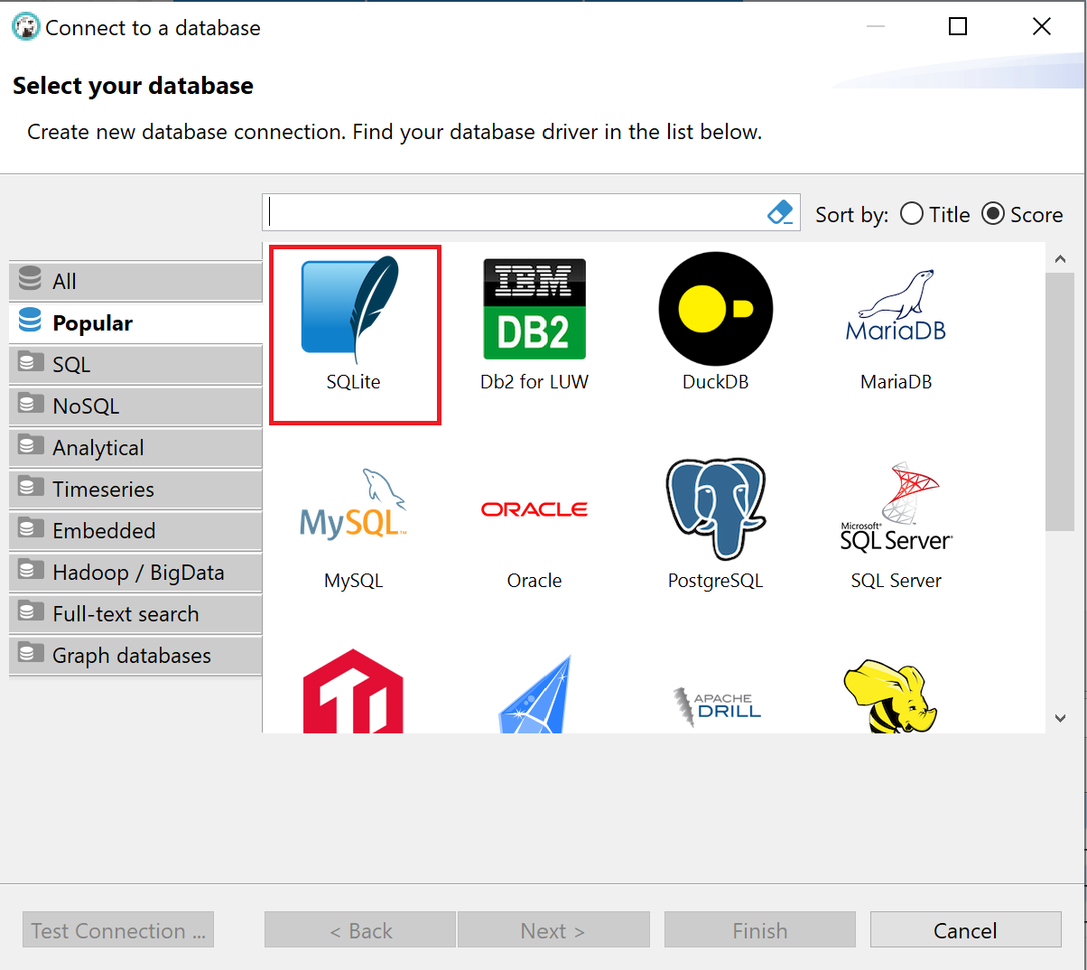

1. Click the next button. On click of the next button it will go to the next screen.

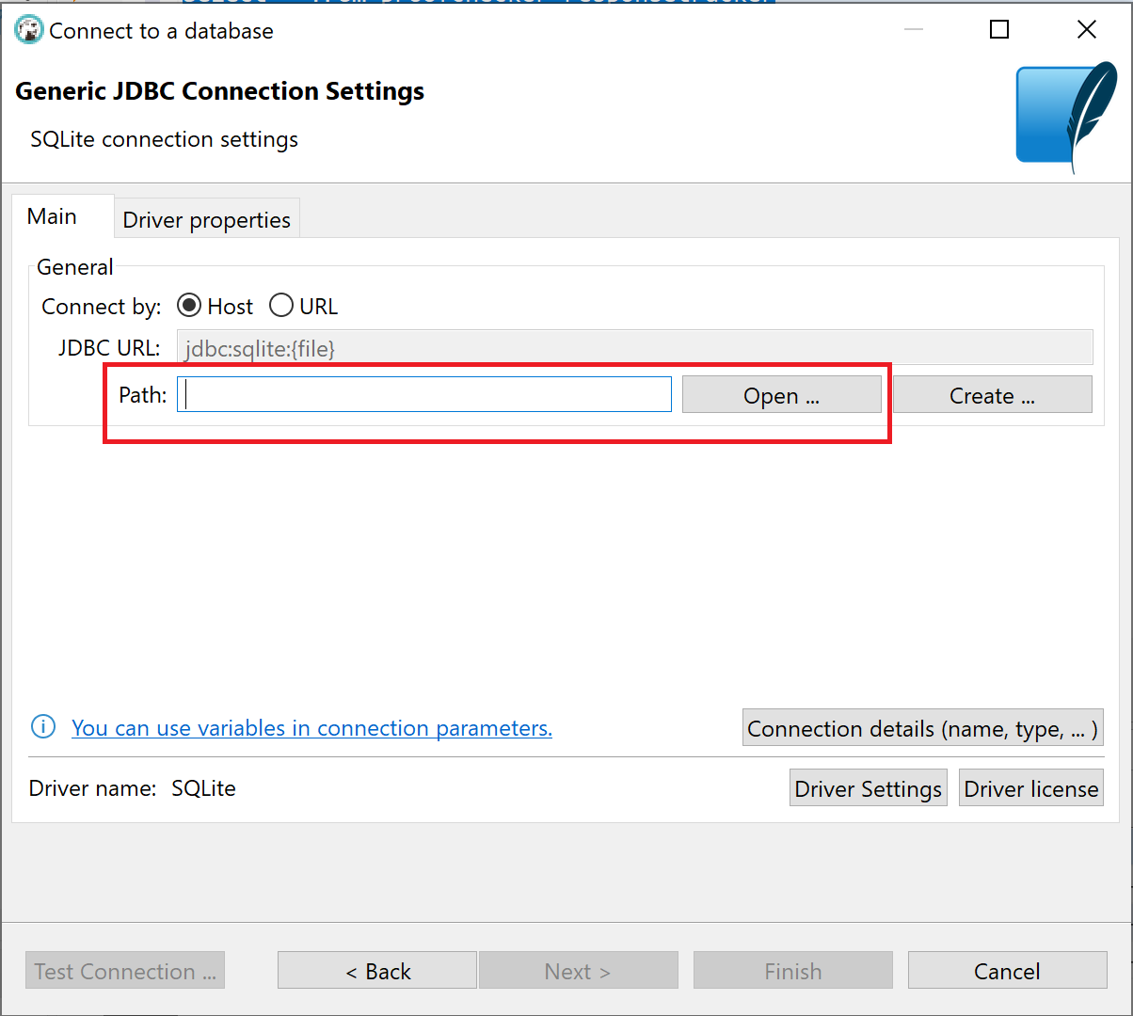

1. Click the “Open” button and select the SQLite database file.

1. Click the Finish button.
2. On click of finish button, database will be connected, and all able will be available to query data. Please refer below screenshot.
3. A screenshot of a computer

   Description automatically generated